**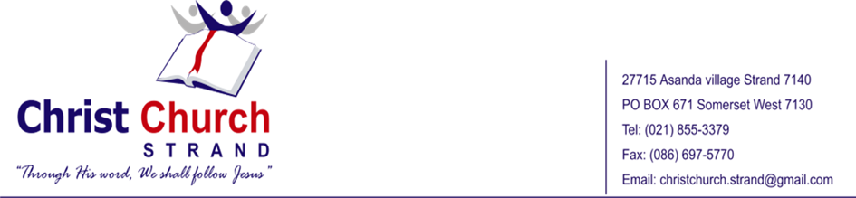  
First Quarterly Newsletter of 2025**

**Family News**

During December, the Makapela family took a well-deserved break and spent a significant amount of time in KwaZulu. It was a refreshing period of rest. We kindly ask for your prayers for the family. As many of you are aware, at the end of this year, Bishop Peter will be concluding his ministry at Christ Church Strand. He will be dedicating his efforts to establishing a new church in Khayamandi, located just outside Stellenbosch. Please pray for him as he embarks on this important mission.

Additionally, we request your prayers for his children. Khanya is completing her matric this year; please pray that she performs well and makes wise decisions regarding her future career path. Above all, we ask for your prayers for their continued walk with Jesus.

**Bishop Peter’s Activities**

In early January, Bishop Peter attended an intensive training course at Mukhanyo Theological College in Pretoria. This training was highly beneficial for both Bishop Peter and the province as they continue to refine their church planting strategy for the Western Cape.

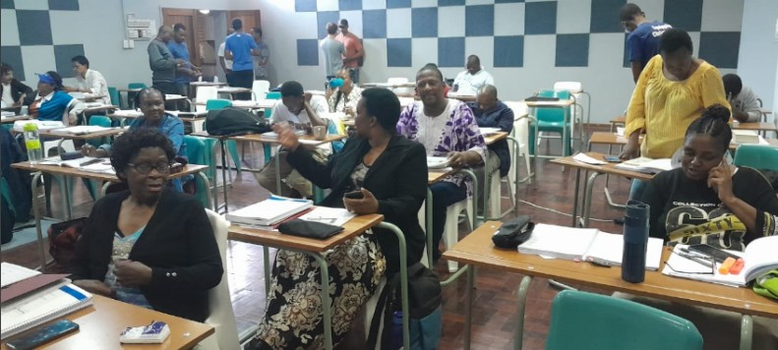

Church Planting Course at Mukhanyo Theological College

Additionally, Bishop Peter participated in the George Whitefield College (GWC) welcome tea and attended a talk by David Fleming at GWC. During this time, he also met with all the new GWC students from the Western Cape over lunch to get to know them and to pray with them.

Furthermore, Bishop Peter has engaged with pastors involved in student ministry across the Cape and participated in the Western Cape Regional Workshop.

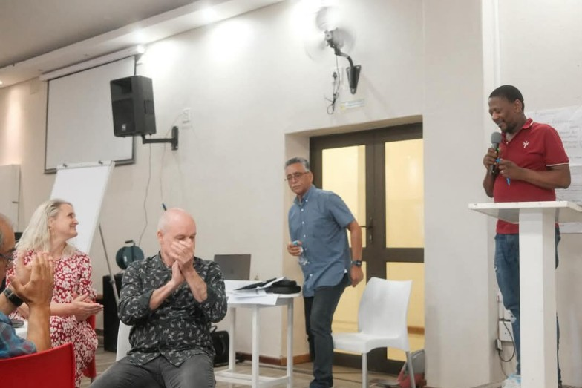

Western Cape Regional Workshop

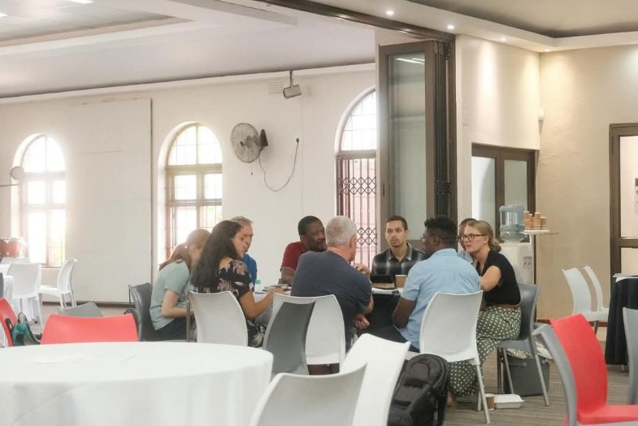

Western Cape Regional Workshop

He was also involved in the two-day National Executive Committee meeting held in Cape Town.

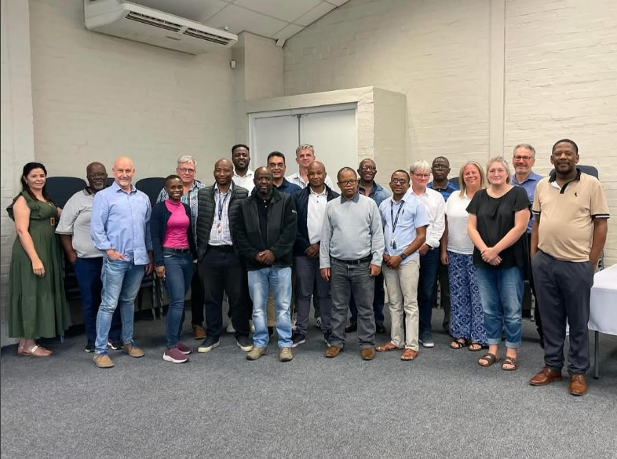

National Executive Meeting

We kindly request your continued prayers for Bishop Peter as he fulfills his dual responsibilities as the Western Cape Area Bishop and the Rector of Christ Church Strand.

**Church**

We give thanks to God for the growth we have witnessed at Christ Church this year. Since January, our average attendance has been between 150 and 180, with the highest recorded attendance reaching 185. We have also observed encouraging growth in both the teenage and children’s ministries. However, we continue to face challenges in the children’s ministry, particularly with the need for more volunteers. We kindly ask for your prayers in this regard.

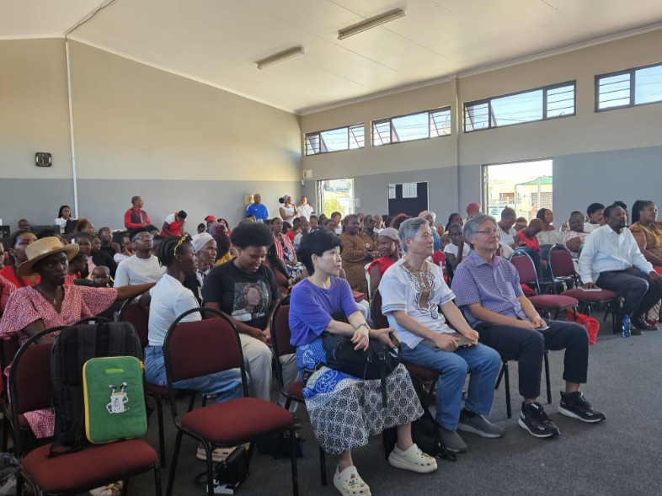

Sunday 10 am Service

This year, we held our annual church picnic and sports day, which provided a wonderful opportunity for fellowship and for members to deepen their connections with one another.

|  |  |  |
| --- | --- | --- |
|  | | |
| Annual Church Picnic and Sports Day | | |
|  |  |  |
|  |  |  |
|  |  |  |
|  |  |  |
| Annual Church Picnic and Sports Day | | |
|  |  |  |

Additionally, we hosted our week of evangelism, which was a valuable time for engaging with non-believers and saw excellent attendance at our evening evangelistic services.

In collaboration with three other churches, we conducted a training session for house church lay leaders. Approximately 21 of our lay leaders participated in this training.

|  |  |  |
| --- | --- | --- |
|  |  |  |
| Training Session for House Church Lay Leaders | | |
|  | | |
|  | | |
|  |  |  |
|  | | |
| Training Session for House Church Lay Leaders | | |

Additionally, Reverend Conwell Muyambo and Nkululeko Msomi participated in the Western Cape Church Planting Cohort. We appreciate your continued support and prayers as we advance these initiatives.

|  |  |  |
| --- | --- | --- |
|  |  |  |
| Church Planting Cohort | | |

Christ Church Strand also had the privilege of sending Sithabile Ngcobo to George Whitefield College (GWC) this year. Sithabile is currently pursuing a Higher Certificate and has been actively involved in leading the children’s ministry in our church. Please continue to pray for her as she balances her leadership responsibilities in the children’s ministry with her academic studies.

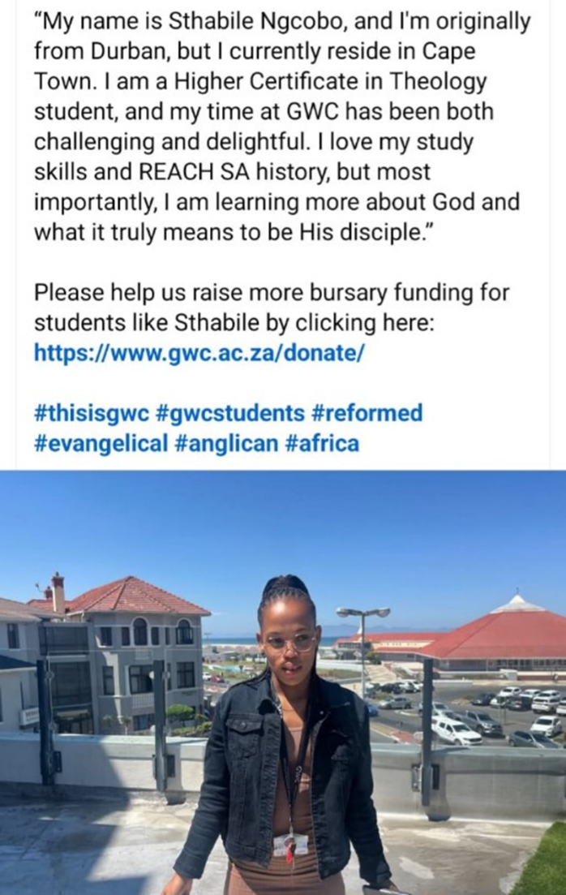

Sthabile Ngcobo at GWC

Furthermore, four of our members attended a discipleship training program at the Bible Institute. We seek your prayers as we deliberate on the implementation of this program within our congregation.

**Khayamandi / Stellenbosch Church Plant**

We are currently holding our meetings in Khayamandi, within the informal settlement known as Azania. These gatherings take place in a private home (a shack). We meet every Wednesday, and on Sundays, the congregation travels to Christ Church Strand using two taxis. At present, our group consists of approximately 11 adults, 8 teenagers, and a few children who have been consistently attending the Wednesday meetings and joining us on Sundays at Christ Church Strand.

In addition, Thembelani is conducting monthly meetings with the teenagers on Saturdays. We are grateful to God for the provision of R25,000, which will allow us to purchase a shack to serve as a meeting space for the time being.

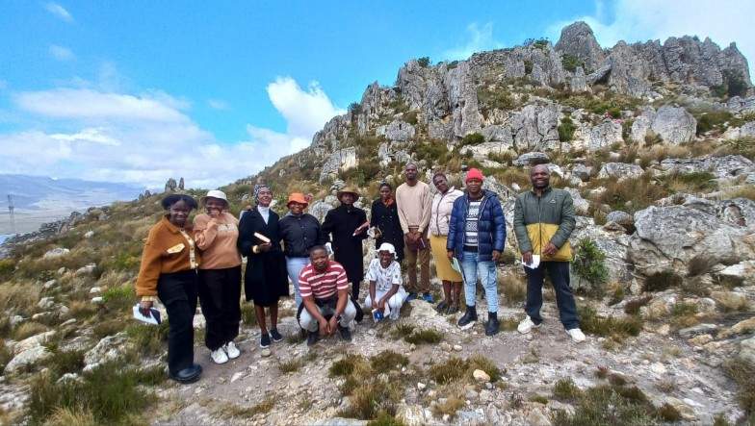

Some of the Brothers and Sisters at Khayamandi

**Plans for Khayamandi**

As many of you are aware, by the end of December 2025, Bishop Peter will conclude his ministry at Christ Church Strand to focus on establishing a church plant in Khayamandi. After much prayer and reflection on their future in ministry, Bishop Peter and his wife recognized the need to step out of their comfort zone and answer the call to serve in underprivileged areas. They asked themselves: if they do not go to these communities to plant a new church, who will?

The plan is for Bishop Peter, in partnership with Christ Church Stellenbosch, to relocate in January 2026. While he will be based at Christ Church Stellenbosch, his primary focus will be on developing Christ Church Khayamandi. Given his responsibilities as the Area Bishop for the Western Cape, Bishop Peter will not undertake this church plant alone. He will be joined by Thembelani, a third-year student at George Whitefield College (GWC), who will move with him to Stellenbosch to work together on this mission.

We are reminded of the Lord’s call to go into the world and make disciples. We firmly believe that church planting is a powerful means of reaching the lost with the gospel of our Lord Jesus Christ. If you would like to partner with us in this mission, please do not hesitate to contact Bishop Peter at pmakapela@gmail.com or via mobile at   
+27 73 767 5510 (0737675510). Alternatively, you may contact Rev. Grant Retief at grant@ccst.co.za or by phone at (021) 887 2669.

**Somlandela Pre-School**

This is the pre-school established by our church in 2012. We were delighted to witness the first cohort of our Grade R learners complete their matric at the end of 2024. Currently, the pre-school employs four teachers, one principal, and one cook, with temporary teachers joining us periodically as needed.

We kindly ask for your prayers as we strive to provide quality Christian education to the community of Zola/Nomzamo and the surrounding areas. Recently, we hosted a sports day in partnership with 10 other pre-schools in our region. While it required significant effort from the teachers, it was an enjoyable and memorable experience for the children.

|  |  |  |
| --- | --- | --- |
|  |  |  |
|  |  |  |
|  |  |  |
| Somlandela Pre-School Sports Day | | |

Please continue to pray for our pre-school, particularly for the safety of the children and teachers. We also welcome volunteers and organizations willing to assist in any capacity. Your support would be greatly appreciated.

**Prayer Requests**

1. **Transition of Leadership:**

By the end of 2025, Bishop Peter will be relocating, and Reverend Siboniso Sibisi will be assuming the role of minister. We kindly request your prayers for a smooth and harmonious transition during this period of change.

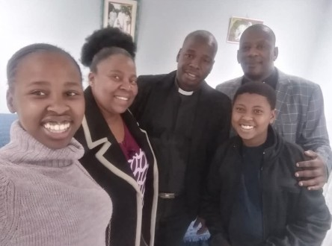

Siboniso Sibisi and his family

1. **Financial Challenges:**

We humbly ask for your prayers regarding the financial difficulties our church is currently facing. Despite these challenges, we are grateful to witness significant growth in our congregation, both numerically and spiritually. The church has been blessed to send two individuals for theological training, and many lay leaders are receiving excellent leadership training. Additionally, we are preparing for our second church plant, with an average Sunday attendance of 150-180. However, due to the socio-economic context of our location—a poorer area—it has been challenging for the church to achieve financial stability. The congregation remains heavily reliant on external support, and this dependency is likely to continue for the foreseeable future. Given the size of our congregation, it is increasingly difficult for a single pastor to manage all responsibilities effectively.

2.1 **Gratitude for Reverend Conwell Muyambo:**

We are deeply thankful to the Lord for Reverend Conwell Muyambo, who initiated the 8 a.m. English service. This service primarily caters to individuals who do not speak our vernacular language, including members from Zimbabwe, Malawi, Uganda, local residents who prefer the early service, and Coloured families. The average attendance for this service is 40-50 people.

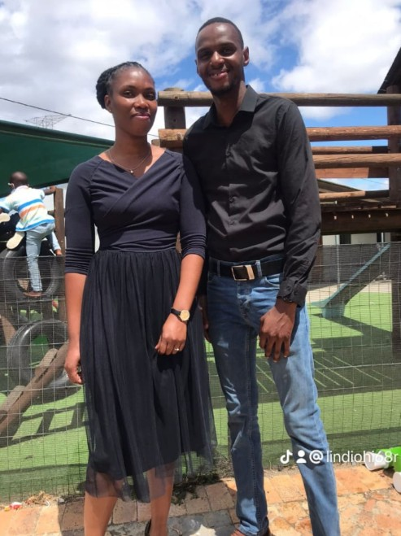

Conwell and Lindiwe Muyambo

2.2 **Appreciation for Siya Zotani:**

We are also grateful for Siya Zotani, who plays a vital role in our music ministry, manages the soup kitchen and sewing projects, and oversees our gardening initiative. Through these projects, we aim to reach out to the lost and serve our community. It is important to note that the scope of this work exceeds the capacity of a single minister.

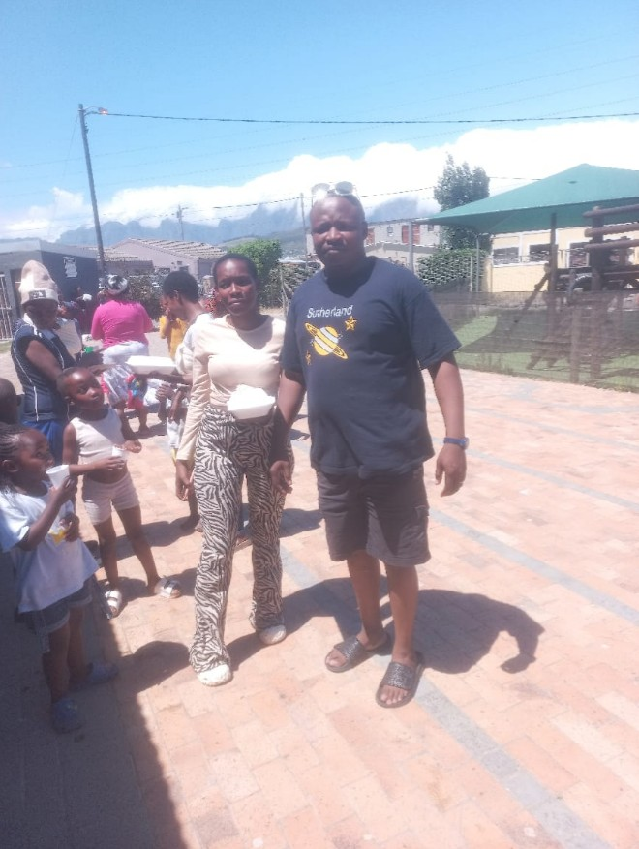

Siya Zotani

2.3 **Urgent Financial Need:**

Due to our current financial constraints, we may soon be forced to reduce the modest stipends we provide to these dedicated brothers or, within six months, ask one of them to step away from ministry. Losing their contributions would significantly impact our church’s mission and outreach.

2.4 **Call for Support:**

We earnestly appeal to friends and supporters who may be able to contribute in any way toward the stipends of these brothers, who have been the backbone of our ministry. Your generosity will enable us to sustain their invaluable work.

2.5 **How to Contribute:**

Contributions can be made monthly or as a one-time donation, starting from as little as R50 (South African Rands). Your financial support will help us retain these brothers in ministry and ensure the continued growth of the Lord’s work in Zola, Nomzamo Strand, and the surrounding areas.

1. **Prayer for More Leaders:**

As our church continues to grow, we are in need of more lay leaders to support and guide our congregation. We kindly ask for your prayers in this regard, that the Lord may raise up dedicated individuals to serve in this capacity.

Thank you for your prayers and support as we navigate these challenges and continue to advance God’s kingdom in our community.

Please keep praying for us.

For more info you can go to our church website: [www.christchurchstrand.co.za](http://www.christchurchstrand.co.za)

Email: christchurch.strand@gmail.com

**__________________________________OOOO__________________________________**